1. select ename, deptno

from emp;

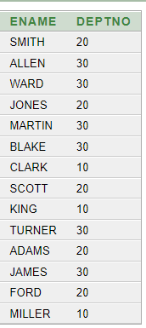

1. select distinct job

from emp

where deptno = 30;

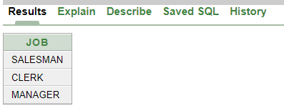

1. select loc

from dept

where deptno = 30;

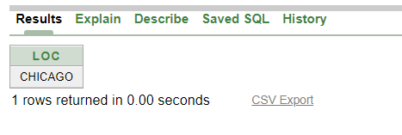

1. select ename, empno

from emp

where comm > 0;

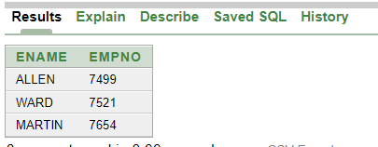

1. select ename, deptno

from emp

where ename like 'A%' or ename like '_A%' or ename like '__A%';

